SOP for Analysis of Stream Water EEM’s via Aqualog
STEP 0: BEFORE YOU START (safety and reminders)
- Always wear gloves when handling cuvettes or any samples for Aqualog Equipment and supplies. Try to remove gloves without touching the outside in between handling samples. Do not touch the mouse or keyboard with your gloves. If you have any doubt they’re dirty change them out.
- The cuvettes are very expensive and the sealed standards cuvettes are even more expensive, so handle gently and carefully.
- We can only use the lamp inside the Aqualog for ~1000 hours before changing it out, so please double and triple check the Aqualog is turned off before leaving (or is set to turn off if using the autosampler)
- IF YOU’RE STARTING A RUN IN THE MORNING
  - You’ll need to warm up the lamp for ~1 hr and run the validation tests
- IF YOU’RE STARTING A RUN IN THE EVENING
  - You don’t need to do the validation testing, just load samples, make new metadata and run.
  - For the new run, create a new file for the data YYYY_MM_DDb, also name your metadata with YYYY_MM_DDb at the end.
STEP 1: INTIAL PREPWORK
- Clean up from the last run
  - Look at the Aqualog notebook lamp hours. If the end time is missing, go into the project file from the day before (C:/Aqualog_Data/2_PNNL_DOM/YYYY_MM_DD), find the text file named “AqualogSampleQLog.txt”, open it and scroll to the bottom. It will have the date and time the lamp was turned off listed in the brackets.
  - Go to Chrome on the Aqualog computer. Click the Aqualog Data bookmark or go to the Aqualog_Data folder in google drive. All the Aqualog files should be stored here.
  - Open the folder 0_Codes and Files, open the Aqualog Notebook file in google drive. You should also be able to access it from the bookmarks bar in chrome. Put the time the lamp turned off in the Aqualog notebook (paper and virtual) under the Lamp Hours tab.
  - Put on gloves.
  - If not already on, turn on the Autosampler (the one that looks like an oven on the right with the vial in it), the switch is in the back on the left side. Open the front, the sample trays should slide forward. Pull the trays out.
  - Using rubbing alcohol (above Aqualog computer) on a kimwipe, rub the sharpie labs on the caps off.
  - Dump any remaining sample from the vials into the sink. Place vials in the bin labeled “To Acid Wash” and the caps in the beaker next to it. These should be above the cabinet by the sink.
  - Upload the last run files to Google Drive
    - Open the Aqualog_Data google drive folder, go to the 1_Validation folder in google drive. Upload all the files in the folder from the day before that are in the 1_Validation folder on the computer (C:/Aqualog_Data/1_Validation) but not in the folder on google drive, by hitting “New” and then “File Upload”. Upload everything in that folder.
    - Repeat with the 2_PNNL_DOM folder

- Turn on the Aqualog using the switch on the left of the instrument toward the back by the plug. Plan for the lamp to warm up for at least an hour before running samples.
  - NOTE: If it ran overnight, the switch will be on, but the lamp will be off. Turn off and turn on again to turn lamp on. If the lamp is still on and you want to start a run, leave it on.
  - Go to Chrome on the Aqualog computer. Click the Aqualog Notebook bookmark or go to the Aqualog_Data folder in google drive. All the Aqualog files should be stored here.
  - Open the folder 0_Codes and Files, open the Aqualog Notebook file in google drive. You should also be able to access it from the bookmarks bar in chrome.
  - Record the lamp hours using the “Lamp Hours” sheet of the Aqualog notebook on google drive. For the virtual book put the date, and then the time so it can keep track when it runs overnight. Always use 24 hour clock for this! Also, fill out this data in the paper Aqualog notebook which is on the shelf above the computer.
    - HINT: Control and ; is the shortcut for today’s date and Control, shift, and ; for the time.
    - NOTE: On the spreadsheet there is a spot to add an extra hour to the lamp time to account for the lamp ignition which is equivalent to about 1 hour of use.
    - NOTE: The computer is set to standard time, so during daylight saving time it will be an hour off, don’t change it!
- Put on gloves and pull the pipet stand and pipet tips off the shelf above the computer and place near the sink. Ensure that these are fully on the counter. You’ll also likely need to get more 0.5 to 10mL pipet tips out.
- Get fresh type 1 water
  - Fresh type 1 water is obtained from the blue and white filter to the right of the Aqualog.
  - Find the brown bottle labeled Type 1 water above the Aqualog computer, bring over to the water filter.
  - Check the display on the water filter to ensure the tank has enough water in it (if it’s low the bar on the left will be blinking).
  - If the water level is too low, refill the tank with DI water from the sink. The tank pulls out from the top left side, and the cap just pulls off. Reinstall the tank.
  - To dispense water, first recirculate to improve water quality. To do this hold the plus and minus button the on the top until the yellow filter symbol at the top changes from blank inside to lines (like the picture below). Let it run for ~1-2 minutes or until the resistance goes to 18.2 MΩ.
  - If it’s not above 16, rerun the recirculation procedure. If it’s still below 16 don’t use the water and let Katie Wampler or Kevin Bladon know, we will likely need to replace the filter.
  - If it is above 16 MΩ you’re good to dispense water, hold the bottle underneath the filter, and press the blue button. When the bottle is full, press the button again to turn off the filter.
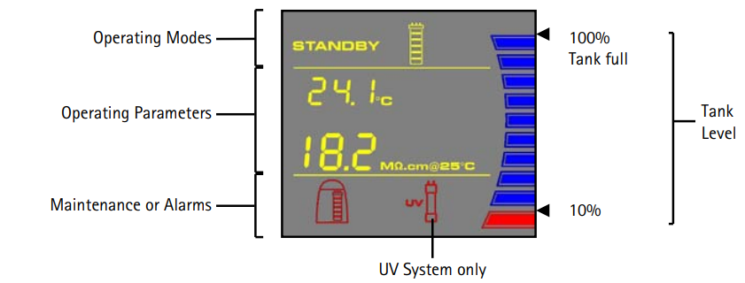
  - Cap the bottle when not in use for the day to prevent dust. At the end of the day, you can discard this water down the sink. Place the empty bottle above the Aqualog computer.
- Remove samples from the refrigerator in Richardson 278.
  - First, you’ll need to figure out how many samples to grab. To determine how many samples you can run, go to the “Autosampler Run” sheet on the Aqualog Notebook.
    - In start time, put today’s date and time (you can use the function =NOW())
    - In end time, put the time you want the run to finish by.
      - If you’re running in the morning, aim to be done by 4p or about an hour before the person running in the evening needs to leave.
      - If you’re running in the evening, aim to be done by 7a the next day.
    - This will calculate and tell you in the yellow box how many samples you’re able to run, not including the required blanks and tea samples. You can run a maximum of 19 actual samples on the instrument.
  - Go to the sample list for this set of samples (should be bookmarked and called master sample list) look at the “run_date” column to see which samples haven’t been run yet (ones with no date) and then select however many samples you can get run in your time by putting today’s date next to those samples.
  - Get those samples out of the cooler. Ideally try to run them in number order. The samples in the “Still to Be Run” are the ones that haven’t run yet. The ones in the “Already Run” bin have already run and don’t need to run again.
  - They should be warmed up to room temperature before running. While there, also grab the tea (see step below).
- Prepare the tea standard. This is used as an instrument check so it’s very important that you measure the volumes carefully.
  - Check the fridge in Richardson 278 on the shelf labeled Bladon-FEWS-PNNL-DOM. In one of the bins there should be a container of Pure Leaf®, unsweetened black tea. Check the date on the label added in sharpie. If it’s within a month, you’re good to go. If not you’ll need to purchase more tea.
    - The café in the dining hall across the street should have Pure Leaf®, unsweetened black tea. Either ask Kevin Bladon to purchase with his OSU credit card or ask to borrow the card to purchase the tea.
    - Label the bottle with the date opened, tea should be exchanged each month.
  - To prepare the standard you’ll add 24.75 mL of Type 1 water to 250 uL of tea.
    - Use the volumetric pipets and mix directly in a clean 30mL amber HDPE bottle. Before starting double check the pipets are at the volumes needed. If not use the dial at the top and turn until the numbers on the side read the correct volume.
    - use the 5-10 mL volumetric pipet to pipet 20 mL of type 1 water into the bottle
    - use the 1-5mL pipet to add 4.75 mL of type 1 water
    - use the 10-1000 uL pipet to add 250 uL of unsweetened black tea
    - NOTE: The pipets have two “stops” on the top button. The first one will get you the volume set on the pipet, if you keep pushing down it will fill the pipet up all the way. When making your standard make sure to stop at the first button. If you’re unsure check the level of liquid on the tip, they’re labeled.
  - Log the lot number in Aqualog lab notebooks (virtual and paper). The lot number is the number below the expiration date.
  - Put the bottle of sweet tea back in the fridge.
  - Leave out the standard for use during your run. At the end of the day discard the standard from the bottle in the sink and rinse the bottle with type 1 water and leave upside down on cuvette holder to dry.
STEP 2: INSTRUMENT CHECKS (once Aqualog has been on for 30m-1h)
If the instrument has already gone through instrument checks in the last 24 hours, you do not need to rerun them.
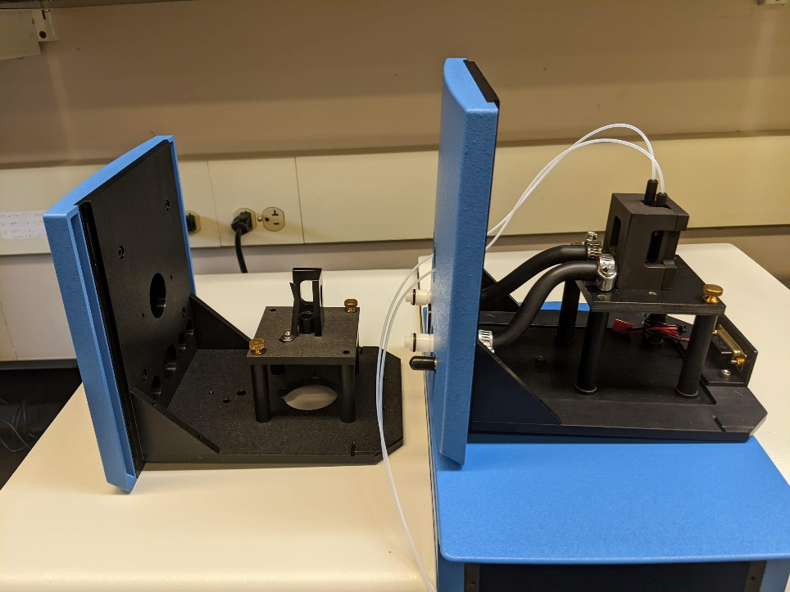
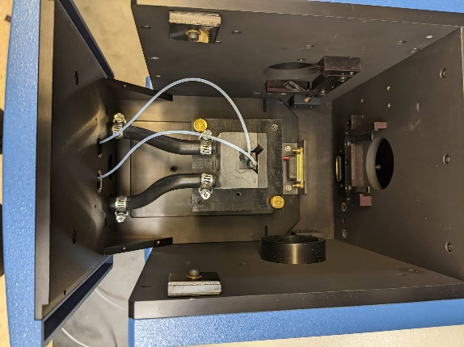
- Before running these tests, you’ll have to switch out the sample compartment. To do this you’ll open the lid of the Aqualog pull the front of the compartment straight towards you. It will have some resistance but will slide out. Set on top of the autosampler and replace with the “basic” sample compartment (the one without tubes coming from it, left).

- Lamp Test
  - NOTE: This test is used to verify lamp performance and peak position.
  - This test is done without a cuvette in the sample chamber. If the empty sample holder is in there that is okay. Once you’ve ensured this, close the sample compartment.
  - In the Aqualog software hit the blue H2O button, then click Spectra, then Absorbance.
    - HINT: If this is the first test of the day, it will open up a window to select the hardware configuration. It should disappear within 3 seconds as the instrument loads up. If it doesn’t, unplug and replug the cream USB cable connecting the computer to the Aqualog and restart the software.
  - Change the following settings in the AquaLog Experiment Setup:
    - Change the data identifier to LampYYMMDD.
    - Run as a blank only.
    - Under wavelength settings change high to 700 nm, low to 200 nm and increment to 1 nm.
  - Click Run.
  - While the test is running, open the “Lamp Test” template found in the 01_Lamp Test google drive file or in the bookmarks.
  - In excel, hit “file” then “make a copy”. Save a copy of the lamp test sheet with the file name “Lamp Test_YYYY_MM_DD”. Under folder, click on the spot where it says “0_Codes and Files”, hit the back arrow, then double click on 1_Validation. Hit the folder with the plus to create a new folder, name it as today’s date (YYYY-MM-DD), click the checkmark, then hit select to save the file here. Click make a copy, this will open up your new file in a new tab
  - In the Aqualog software, when the project name window pops up, hit browse and navigate to the Aqualog_Data file (C:\Aqualog_Data), open the Validation folder, and create a new folder for today’s date (YYYY_MM_DD).
    - HINT: Don’t try to move, delete, or modify files here, it will cause the software to stop responding. You can only create folders if needed and save files.
    - Name the project as YYYY_MM_DD and hit save. Hit OK.
  - From the Abs Spectrum Blank workbook in the Aqualog software, copy columns B(Y) and D(Y) into the matching locations in the Lamp Test spreadsheet. This will autopopulate the peak maximum section and graph. The wavelength should be 467 nm, which will result in green pass values for both detectors. Additionally, the reference peak (Ref) should be above 6, it will turn green if it passes this test.
    - If it’s lower than 6 but above 5, you can still run samples but let Katie Wampler or Kevin Bladon know. If it’s below 5 do not run samples for the day.
    - Record the wavelength and peak absorbance in the virtual and paper notebooks under “Lamp Test”.
    - HINT: You can paste these values from the lamp test spreadsheet but if you do make sure to “paste values” since they’re an equation in the original spreadsheet.
  - Once edits have saved you can close this file.
- Water Raman SNR (signal to noise ratio) and Emission Calibration Test.
  - NOTE: This test is used to check the wavelength calibration of the CCD detector.
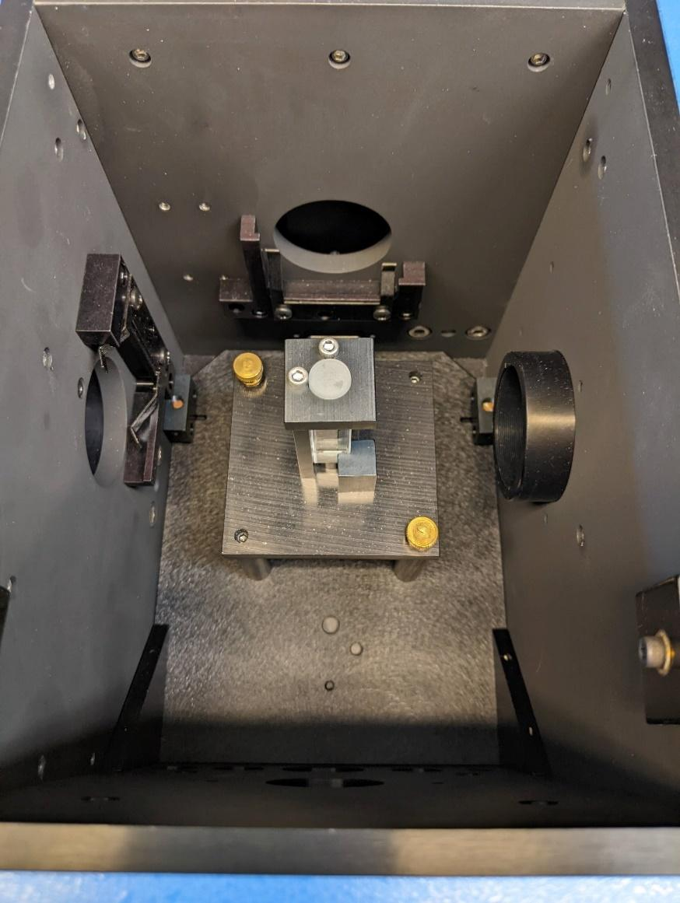
  - Ensure the sealed water cuvette in the sample holder is in the Aqualog. The silver screws on top should be facing the top and left of the sample compartment (see figure below).
  - To run the scan, go to the collect menu, then Aqualog service only menu, then Water Raman SNR and Emission Calibration.
  - Change the data identifier to RSNYYMMDD, then hit run.
  - When the run is done a graph will pop up, at the top is a table, both values should say “Pass”.
  - NOTE: If the test shows a fail value, allow the instrument to warm about another 30 minutes and rerun the test. If it repeatedly fails contact Kevin Bladon or Katie Wampler.
  - Record the peak and SNR in the virtual and paper lab notebooks under “Water Raman SNR”.
- Raman Scattering Area Unit Tool (RU)
  - NOTE: This test is used to check the lamp stability. This test excites the water at 350 nm and looks for the emission from 247 to 829 nm.
  - On the second menu bar in the software, click on the Raman Scatting Area Unit button (the blue RU button) This will open an experiment setup window, change the following parameters:
    - Data Identifier: RSYYMMDD (RS220716)
    - Integration: 10s
    - Increment: 2.33 nm (4 pixel)
    - CCD Gain: Medium
    - NOTE: It is very important that you use the same increment and CCD gain as you plan to use for your samples, as this test is used to normalize all your data. Integration times can be adjusted later.
  - Click run.
  - The Raman Area Graph should pop up automatically, here you will check that the lamp is performing appropriately. The result should look like this:
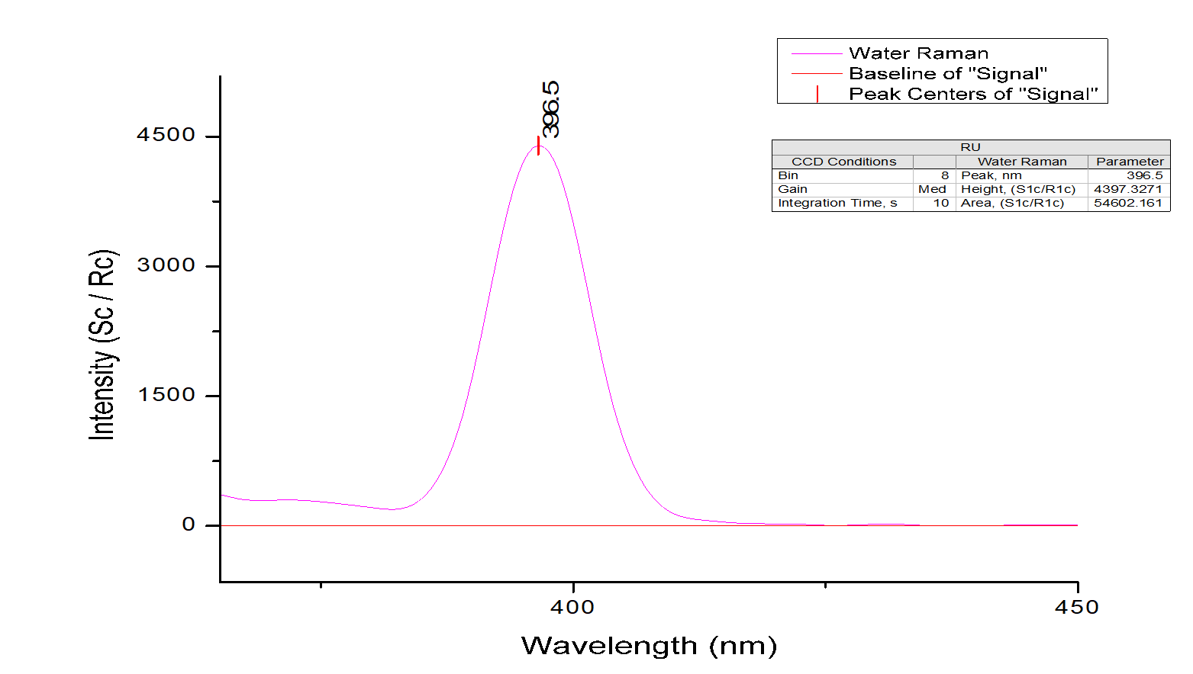
  - Under the “Raman Normalize” tab of the virtual lab notebook, enter the date, integration time, increment, and CCD gain. Under the “Run 1” section, enter the peak wavelength and peak area.
  - Next, in the Aqualog software, go to the spreadsheet at the bottom labeled “RSU Adjust”. Ensure the integration time in column C is set to 1. Then copy the RSU Adjust area in column D. Put this in the Aqualog notebook under the Run 1 section, RSU Adjust Area column. Also fill out this data in the paper Aqualog notebook.
  - Repeat all the steps a second time, you can keep the same data identifier. Put these results in the “Run 2” section of the data.
  - Once you’ve filled out the RSU adjust for run 2 in the Aqualog notebook, the spreadsheet will automatically calculate the percent difference between the two runs. This value needs to be below 1%, if it’s not let the lamp warm up longer. Record the RSU adjust difference in the paper notebook.
  - HINT: The lamp needs to have a peak at 397 ± 1 nm with a peak area greater than 20,000. If your values meet these requirements the cell should turn green. If not, it does not pass this test. Let the lamp warm up longer (~30 minutes) and repeat. If it still fails, contact Katie Wampler or Kevin Bladon.
- Quinine Sulfate Units
  - Replace the sealed water holder with the sampler holder. Put the sealed water back in the drawer below the Aqualog.
  - Pull out the Starna Quinine Sulfate standards from the second drawer down below the Aqualog, they’ll be in a wooden box.
  - On the main toolbar, click the Quinine Sulfate Units button (blue button with QU).
  - In the experiment setup window adjust the following:
    - Integration (s): 0.05
    - Increment (nm): 2.33 nm (4 pixel)
    - CCD gain: Medium
    - Data Identifier: QSYYMMDD
    - Select sample and blank and collect blank
    - Click the three dots next to “collect blank” and save to the validation folder you’ve created for the day using the file name QSBYYYYMMDD.blank, if it doesn’t end in “.blank” it will throw up an error. Hit open.
  - Click Run. It will ask you to put the blank in.
  - Ensure the blank (the one that says blank on the cap) is in the sample holder and it has no dust on it and press OK. It will run the test on the blank (it happens almost instantaneously).
  - When prompted (it will say “Insert Sample”), switch the blank for the Quinine Sulfate sample cuvette and click OK. This will also take about a second or less and then it will pull up the spectrum which should look like this:

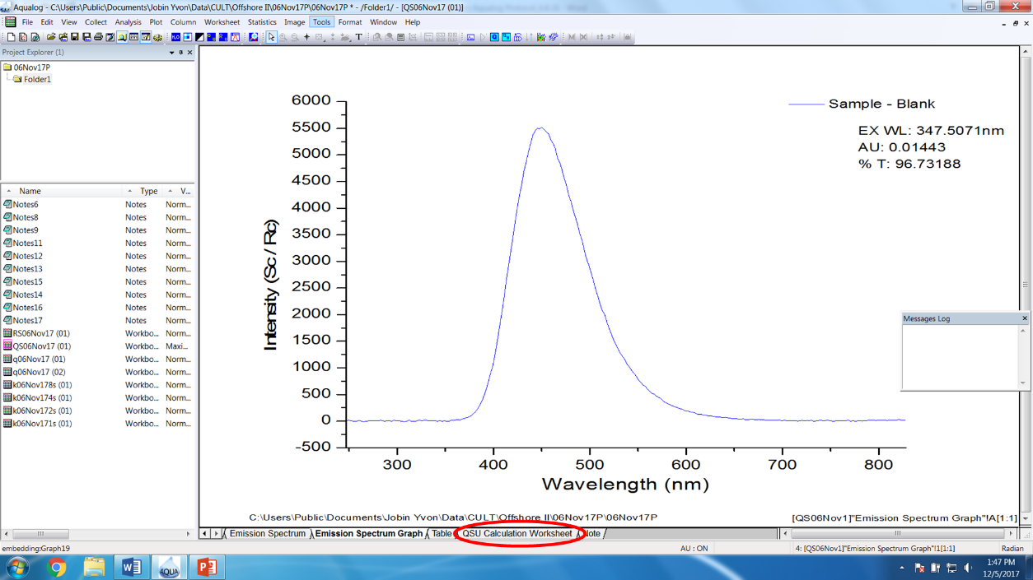
  - Log the test in the virtual and paper notebooks under “Quinine Sulfate Units”, record the sample conditions (integration time, increment, and CCD gain) along with the QSU peak area.
    - To get the QSU peak area click on the QSU calculation worksheet tab, and copy the value from the G(Y) column.
  - If there is a significant drop (>5000) in the QSU, clean the cuvettes and rerun. If the drop remains let the instrument warm up another 30 minutes.
  - Put the cuvettes back in the box and put back in the drawer.
- Get the Raman Normalization Area. You will now perform the same raman test you do with the sealed water with the flow cell to get a normalization factor for your data. This is the only test you’ll do in the morning and evening runs.


  - To do this you’ll open the lid of the Aqualog and pull the front of the compartment straight towards you. It will have some resistance but will slide out. Set on the shelf and replace with the autosampler sample compartment (the one with the tubes coming from it, right).

  - In the Aqualog software, hit the Sample Q button (the blue button with the Q). Click the arrow and select the top row that’s blank. Hit open.
  - Click on the scan settings on the side, then check the Enable Injector option towards the bottom. This will cause an Injector tab to appear on the side. Click that.
  - Go to the configuration tab at the top and hit test connection. As long as the Autosampler is on, it should find it and all the boxes will become selectable.
  - Hit the Wash Needle button, it will ask if you’re sure, say yes.
  - After it is done with that hit the Wash Loop button, it will also ask if you’re sure, say yes. Wash the loop three times. Then hit cancel on the Sample Q method and once more to get back to the main page.
  - On the second menu bar in the software, click on the Raman Scatting Area Unit button (the blue RU button) This will open an experiment setup window, change the following parameters:
    - Data Identifier: RSUYYMMDD (RSU220716)
    - Integration: 10s
    - Increment: 2.33 nm (4 pixel)
    - CCD Gain: Medium
    - NOTE: It is very important that you use the same increment and CCD gain as you plan to use for your samples, as this test is used to normalize all your data. Integration times can be adjusted later.
  - Under the “Raman Units” tab of the virtual lab notebook, enter the date, integration time, increment, and CCD gain. After the test has run, enter the peak wavelength and peak area.
  - Next, in the Aqualog software, go to the spreadsheet at the bottom labeled “RSU Adjust”. Ensure the integration time in column C is set to 1. Then copy the RSU Adjust area in column D. Put this in the Aqualog notebook under RSU Adjust Area column. Also fill out this data in the paper Aqualog notebook.
- This value should be quite similar to the previous values (RSU should be around 1500, if it’s not double check you set the run parameters right and rerun.) It’s very important this is done correctly as all the data will be normalized based on this value.
- After you’ve run all the preceding tests you’re good to start running samples. Hit save on the toolbar in the Aqualog software to save the project. Then go to file and close. This will close the project with the validation runs.

Step 3: Run Samples via the Autosampler
- Setup Sample Run. Open up the metatable_manual google sheet on drive or use the bookmark link
  - Hit file and make a copy save the metadata file as metatable_manual_YYYY_MM_DD. Hit save. Under folder, click on the spot where it says “0_Codes and Files”, hit the back arrow, then double click on 2_PNNL_DOM. Hit the folder with the plus to create a new folder, name it as today’s date (YYYY-MM-DD), click the checkmark, then hit select to save the file here. Click make a copy, this will open up your new file in a new tab.
  - To start a run you’ll put a blank, put “Sample Blank” in the description cell, and put BLKYYMMDD# in the data identifier cell, where the date is today’s date and # is 1 for this first blank, 2 for the second blank, etc.
  - Your second sample will always be a tea standard sample. Put “PreTea 1% SRM” in the description, the data identifier will be preTeaYYMMDD.
  - Starting with the lowest number, add these samples in site order to your metadata, filling out all the previously mentioned columns.
  - Every ten normal samples / tea samples (so your first blank will be after the tea and 9 additional samples), enter an additional blank sample. Follow the formatting as the first blank, but change the number at the end to 2, 3, etc.
  - At the end of your run you should have postTea sample. Put “PostTea 1% SRM” in the description, the data identifier will be postTeaYYMMDD.
  - Then add one additional blank. Put “Sample Blank” in the description cell, and put BLKYYMMDD# in the data identifier cell, where the date is today’s date and the number is one more than your last blank.
  - Once you’ve arranged your samples, fill out the rest of the metadata:
    - index: this is just the number of the sample in the run, the first sample should have a 1, the second a 2, etc.
    - analysis_date: this is today’s date, in the format YYYY-MM-DD
    - description: this is a short bit of information on the sample, if the sites have names put that here. For blanks put “instrument blank #”, for the McKenzie SSN sites, they don’t have names so just put their site number (MCSN###).
    - data_identifier: this is the label of the sample in the Aqualog and will be the same of any resulting files, it’s very important to make sure this matches the label on the bottle. Generally this should be in the form of study code, site number, date, time (MCSN###YYMMDDHHMM) there should be no spaces, dashes, or underscores and use the two digit year.
      - For the McKenzie SSN project these labels have been created already they’re in the spreadsheet called “Master_Sample_List_YYYY_MM_DD” under the 0_Codes and Files folder. The samples names are under the Aqualog.Name column. Find your sites and copy into the metadata.
      - Once you grab your sites, put a 1 in the column next to it, indicating that those samples have been run.
    - replicate_no: a space if you’re running the same sample twice, generally you won’t do this, so put in a 1 for all samples.
    - integration_time: this is how long it stays at each wavelength, usually all samples will run at 5s.
    - dilution: this will almost always be 1, indicating no dilution.
    - RSU_area_1s: take the RSU adjust value from the Raman Units page of the Aqualog notebook, paste that here.
    - run_type: This will be “sampleQ” if you’re running samples using the autosampler or sampleQ on the software (this will likely be pretty much always). If you’re running one sample at a time use “manual” (the current SOP does not include directions on how to do this).
    - DOC_mg_L: a spot to put the DOC results, you likely won’t have those results when running samples. Leave blank.
  - Each run should start with two blanks, one the instrument views as a blank and one that it thinks is a sample. Only the sample blanks should go in the metadata. So, if you have a full run it will only show up to 23 on your index. A full run should look like this:
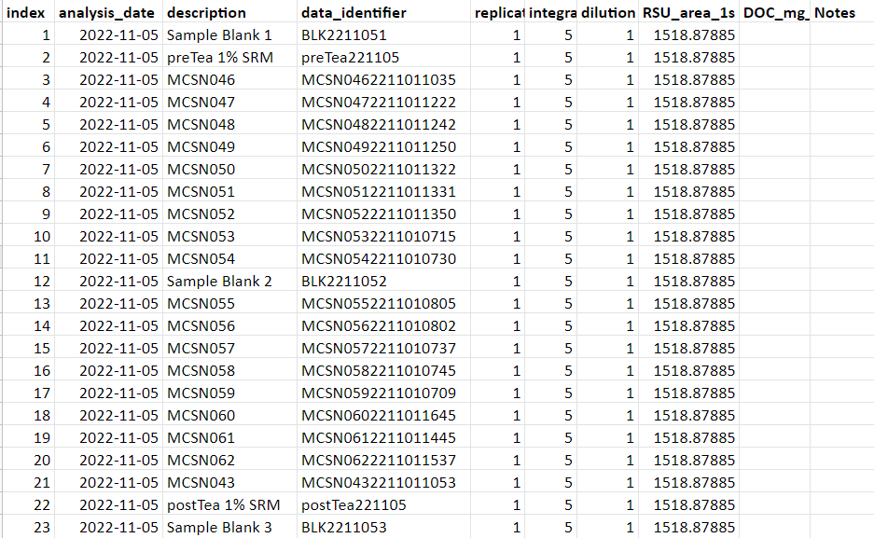

- Prep the Autosampler.
  - In the Aqualog software, hit the blue Q button. Either look in the recent method files for “MCSN Method” (C:/Aqualog Data/0_Codes and Files/Sample Q Templates), select and hit open.
  - In file settings, under output folder, hit browse, and navigate to 2_PNNL_DOM, create a new folder with today’s date, then select that folder and hit Okay.
  - Under scan settings ensure the integration time is set to 5s.
  - If you’re running samples in the morning uncheck “Turn Off Xenon lamp After Completion”, if you’re running samples at night ensure this is checked.
  - Under data processing, Absorbance, Workbook, Blank XYY, and Sample XYY should be checked. Everything else should be unchecked.
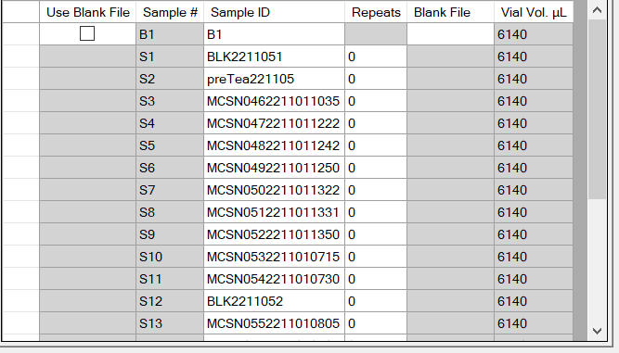
  - Lastly, go to the Injector tab, under ‘Blank/Sample groups’, you’ll have 1 blank, then under samples per blank, change to the number of samples you’re running for the day. This should be the maximum index number on your metadata. Repeats per blank is zero. Hit Add.
  - Copy the data_identifier column (without the header) into the Sample ID column of your table in the Aqualog software. To do this it must be exactly the same number of rows, click in the first sample ID (not the blank) and copy. It should look like this:
  - Change the Sample ID for the Blank to DIYYMMDD5s
  - In the configuration tab, hit test connection, to recognize the autosampler. Once it’s loaded, hit “Wash Needle”, it will ask if you’re sure, say yes.
  - Once the needle has washed (the boxes will be ungrayed out), hit Wash Loop, it will once again ask if you’re sure, say yes.
  - While it’s washing, you can hit save, then save the sample Q file in 2_PNNL_DOM under today’s date, name it “MCSN Method_YYYY_MM_DD”, then hit save.
- Load Samples into the Trays
  - Ensuring you’re wearing gloves, open the autosampler door, and pull the trays out (they should come forward on their own, don’t pull them). They may already be out if you removed samples from the previous run.
  - Pull out as many clean vials (in the white box above the Aqualog), as you have samples, including blanks. Put a cap on each sample, and put into the sample trays. Grab a fine tip sharpie and bring the trays over to the computer.
  - Under the injector tab, hit the Vial Trays tab at the top. This will pull up a diagram with the location your samples should go. Placing your mouse over place in the tray on the diagram will show the sample number that goes there. Label the vial caps, with the sample number (or B for blank or T for tea) so you know what sample goes where. Double check that the vials are in the right spots after they’re all labeled. You can do this by hitting the vial assignments tab.
  - After vial caps are labeled, bring the trays over to the sink and your samples. Adjust the 10 mL pipet to 8.5 mL. Using a clean pipet tip for each unique sample (you can use the same one for all the blank samples), add 8.5 mL of sample to each vial ensuring the correct sample goes in the correct labeled vial. Do this one vial at a time so you ensure it goes back in the right spot.
    - For the blanks, put in the Type 1 water
    - For the tea, put in the tea standard you prepared earlier
    - If you listed the samples in number order, it’s easiest to pull all your samples out and arrange in number order. Just double check as you’re putting the sample in the number that matches the number on the vial cap.
  - After the samples are put in, triple check the samples are in the same order as the metadata shows.
  - Place the trays in the autosampler, they should snap in/ lay completely flat. Slide in the muffcooling tray, and close the door.
- Start the Autosampler Run
  - Before you hit run on the software, ensure the sample chamber with the tubing is in the Aqualog. This is critical!
  - Also double check that the lamp is set to turn off if you’re running a batch at night.
  - Lastly, check that the output folder is set to today’s date.
  - Once this is done, ensure your method is selected and hit “Run”, it will ask you to verify the vial plate, tray, number of samples, and amount of wash water. Please double check these things before hitting OK.
  - The Runtime Monitor will show up in the upper left of the screen so you can see where it’s at.
  - Stay until the blank is collected. As it’s acquiring data, keep an eye on the spectra, it should look like the figure below without any extra points on it.
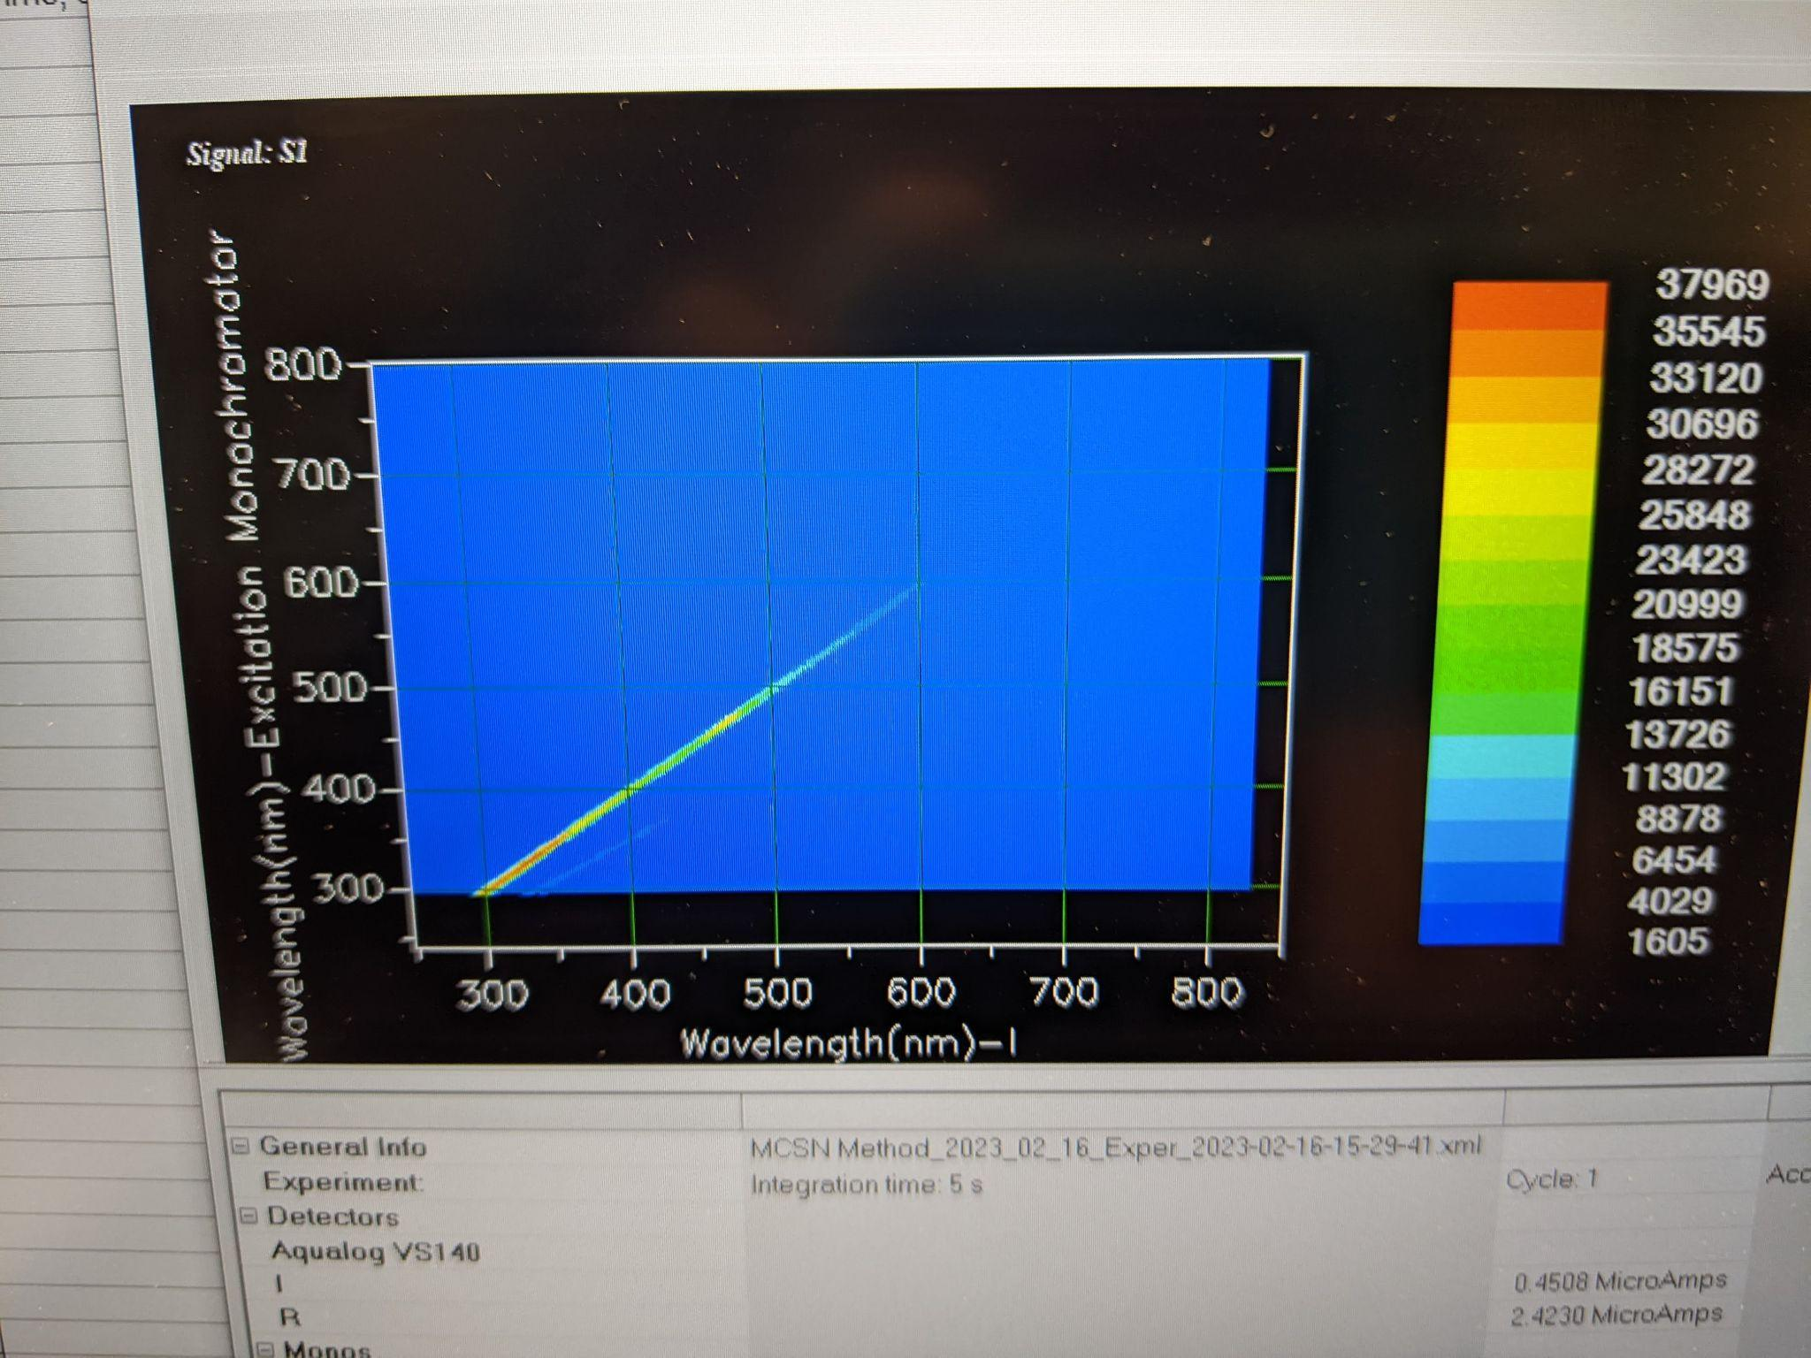
  - If you see anything weird:
    - Abort the run
    - Clean the cuvette by gently wiping the outside of the cuvette with a lens paper,
    - Refill the blank vial
    - Start the run again
    - Wait until you have a clean run
      - If blank is still not correct:
        - Clean the cuvette as outlined in section 9-1 in the Aqualog operation manual (this involves removing the cuvette and is a ~24 hour process)
- Clean Up (regardless of running in the morning or evening)
  - Return the pipets and pipet tips to their spot above the Aqualog.
  - If used, return the cuvette and cap to the acid bath, make sure to wear full PPE. When you put the cuvette in, ensure there are no air bubbles by lightly tapping it.
  - Return samples to the fridge. Place in the bin labeled “Already Run”.
  - Discard the tea standard from the bottle in the sink and rinse the bottle with type 1 water and leave upside down on cuvette holder to dry.

SUPPLEMENTAL SOP’s
2.1 Acid Washing Aqualog Vials
- Grab the dirty vials from the bin on top of the cabinet by the sink in 273. Use isopropyl alcohol to remove the sharpie from the caps.
- Find one of the big 1000 mL plastic beakers and one of the 1000 mL glass beakers. They should be on the drying racks in either 273 or 269.
- Place all the caps in the glass beaker.
- Shake out any excess water and place the vials in the plastic beaker.
- Take both over to the fume hood in 269.
- Put on PPE (disposable gloves, face shield, lab coat, and chemical gloves), place the glass beaker with caps in it in the acid bath. Use the 250 mL beaker near the bath to fill the large beaker with acid. When it’s full, place the large watch glass on top, ensuring there are no air bubbles in the caps.
- Careful not to splash acid, use the plastic beaker to slide the glass vials into the acid bath. Once they are in, go through the vials and remove any air bubbles by pulling the vials to the surface to let the air escape.
- Let the vials and caps sit for at least 24 hours. Once the fume hood doors are shut you can remove your PPE and wash your hands.

- To remove the vials, grab the cart from 271, place a plastic tub or two on the cart to place the washed vials.
- Put on your PPE (disposable gloves, face shield, lab coat, and chemical gloves).
- Remove the caps by picking up the beaker and using the watch glass and your gloved hand to pour out as much acid as possible while preventing the caps from falling out. When you’ve removed as much acid as you can, stick the entire beaker and watch glass in one of the tubs.
- Remove the vials carefully, pouring out the acid and placing them in a tub.
- Once all the vials are removed, place the acid gloves in the same tub so they’re drip acid. Keep all other PPE on.
- Bring the cart to the sink in 273. Grab two clean tubs from under the counter by the Aqualog. One will be for caps and one for vials.
- Put on the acid gloves.
- Rinse the caps by letting the beaker fill up with DI water before draining. Do this 4-5 times before draining as much water as you can. Then place the rinsed caps in one of the clean bins.
- Place the bin with vials in it in the sink, let it fill with DI water to rinse the outsides. Then pull vials one to three out at a time and rinse three times with DI water. Place in the clean bin.
- The vials and caps need to be fully dry before they’re put away. To do this you’ll place them in the muffle furnace at a low temperature to encourage drying. The furnace should be no hotter than 60C.
- Shake as much water as you can from the vials and then place in the furnace upright.
- For the caps, make a boat out of foil (or use foil bread pan) and place all the caps inside. Place in the furnace.
- Let heat for at least 2 hours, maximum 8 hours until dry.
- Once caps and vials are dry, put on gloves and screw caps on vials. The vials with caps on them can go back in the box for reuse.
2.2 Check if the Lamp is On
- To double check if the Aqualog lamp is on or off, go to the Aqualog software. Hit the blue H20 button. Then choose spectra then emission 2D.
- In the experiment setup, set the wavelength settings park to 550 nm, then click the RTC button at the bottom. This will set it to emit light at a wavelength of 550 nm (green) and then opens up real time control.
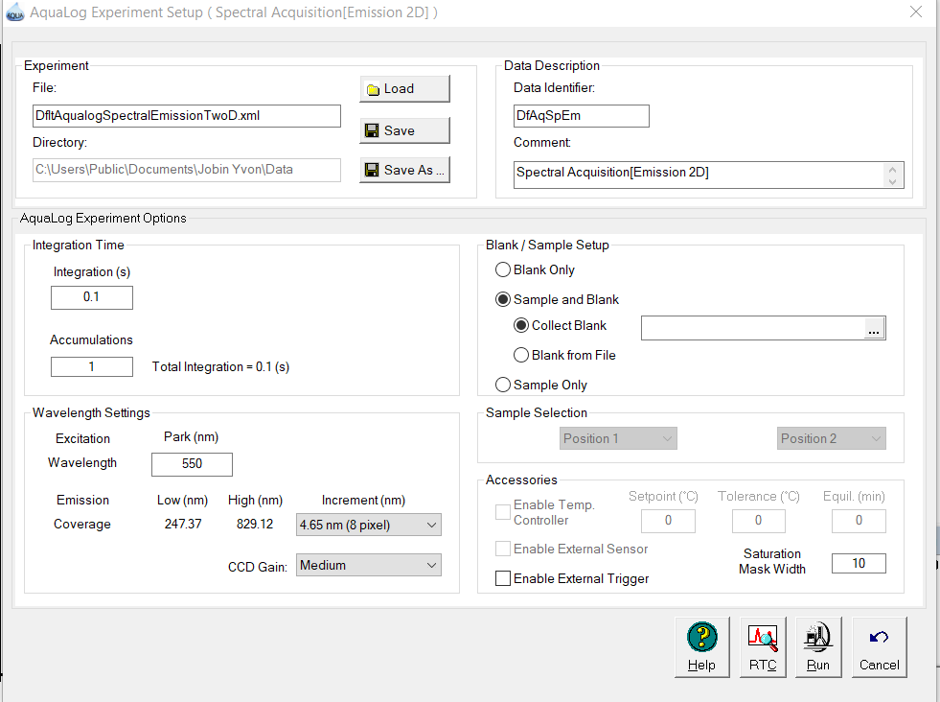
- At the bottom, move the slider to open the shutter. You can open the lid of the sample chamber.
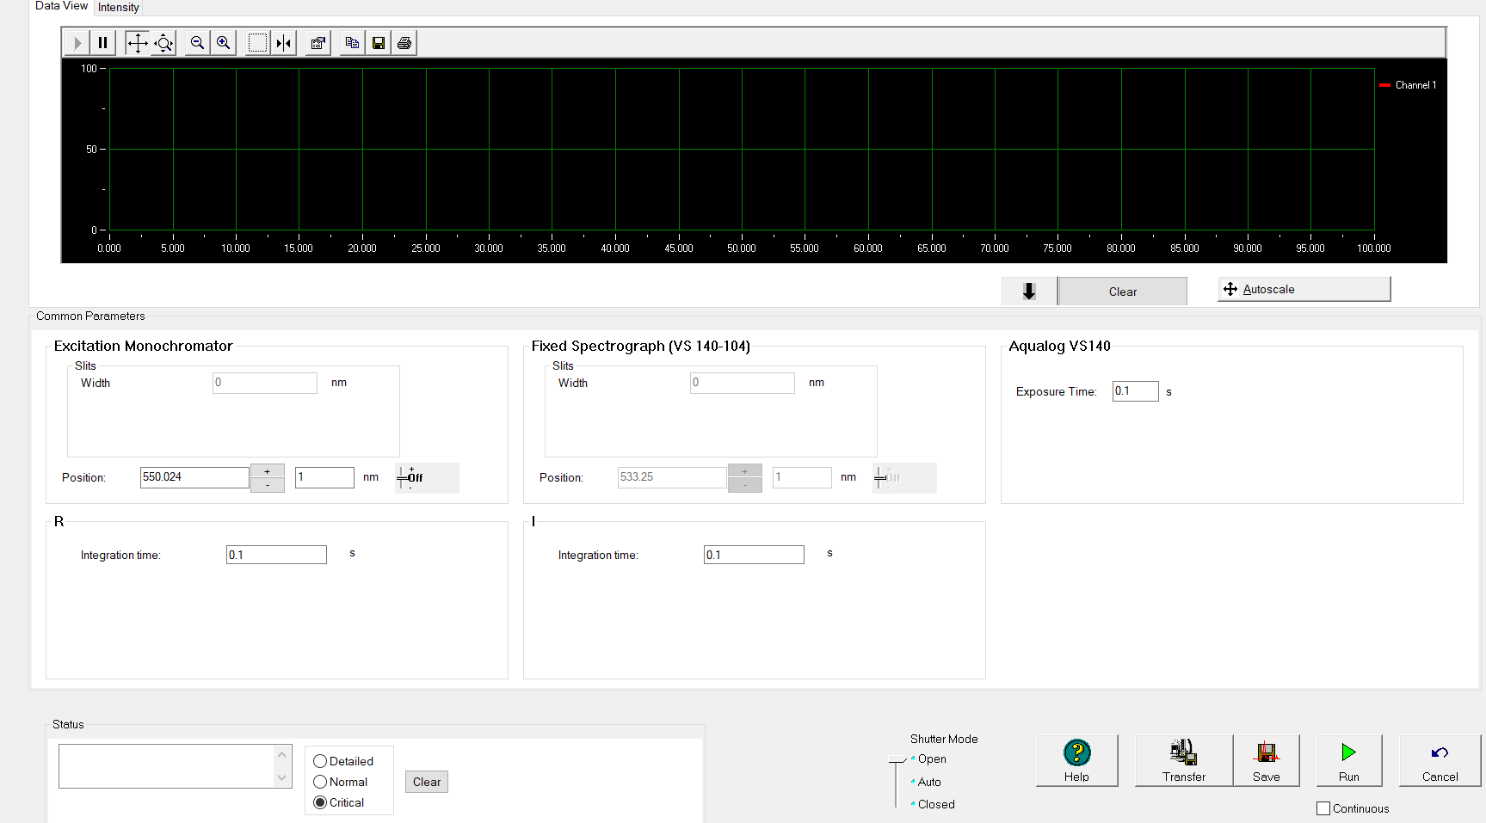
- Place a white piece of paper to the left of the cuvette.
- If you see a green square the lamp is on. If you don’t the lamp is off.
- When you’re done checking, set the shutter back to auto then hit cancel.

